**Lab: 01**

Advanced Object-Oriented Programming

PROG2200

Date: September 28, 2022

By: Diana Hakim - W0420915

# General

## Demonstrate that you have made multiple commits as you went through the Learning C# course: at least 5.

<https://github.com/Diana-W0420915/PROG2200>

Figure 1

## Show that you have the right README and .gitignore for Visual Studio. Update the Readme file to state your name and your student number. Also, arrange your project according to the structure outlined above.

<https://github.com/Diana-W0420915/PROG2200>

|  |  |
| --- | --- |
| Figure 2 README.md with my name and student number written inside | Figure 3 .gitignore for Visual Studio |

# Module 1: Basics

## Take the Challenge 1 (Multiple Choice) and add two more questions of your choices to it.

### Output Example

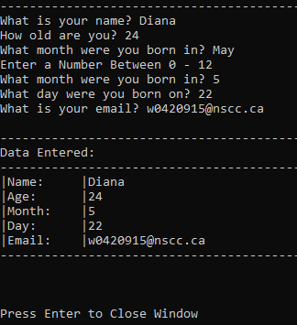

### Code Main Function

### Code Sample

## Alter Challenge 2 (Passcode) so that the user can change the password after authenticating.

Question: Is an else...if the best option for checking the secret? Simplify the code to not use

else…if as described.

### Output Examples

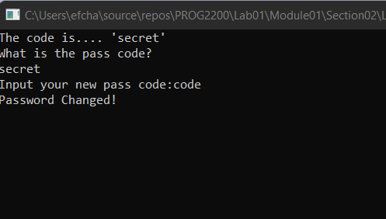

### Code Main Function

### Code Sample

## Change Challenge 3 (Loop Counting) to be only 2 loops (instead of 3) with a conditional

### Output Examples

### Code Main Function

### Code Sample

## In Challenge 4 (Student Manager) there are two arrays: studentNames and studentGrades. How could you replace these with a single two-dimensional array?

### Output Examples

### Code Main Function

### Code Sample

# Module 2: OOP in C#

## Challenge 5

Change the Survey console app to be a full Zodiac Calculator. Requirements: Also take the day of the month as an input. Use a switch statement to calculate what star sign matches the month and date. You should validate that the user entered a number for month and date.

### Code Main Function

### Code Sample

Please read commented notes I mentioned that this could be done with one if statement rather than the switch and case here. Under case 1 was the scheme I did originally.

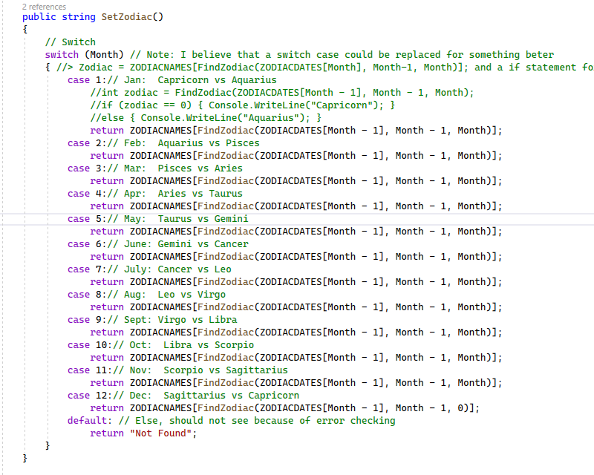

# Module 3: Exception Handling & Debugging

## Section 1

### Output Example

### Code Main Function

### Code Sample

# Module 4

## Section 1 - Enums

### Output Example

### Code Samples

## Section 2 - out vs ref

### Output Example

### Code

## Section 3 - Interfaces

### Output Example

### Code Main Function

### Code Samples

## Section 4 - Events

### Output Example

### Code Main Function

### Code Sample



